**SAP ABAP**

**Assignment – 1**

Makt Report

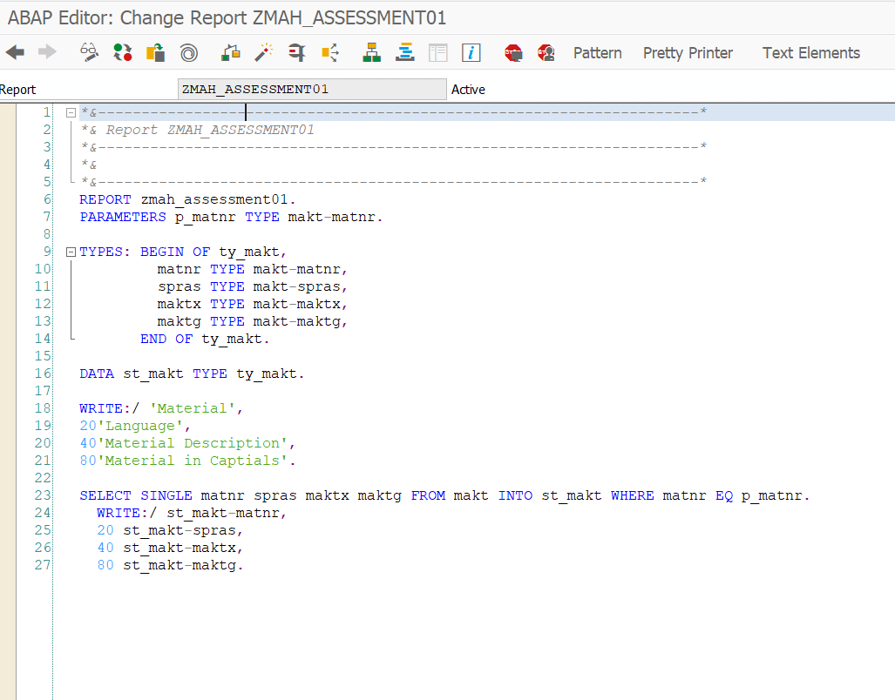

Result:

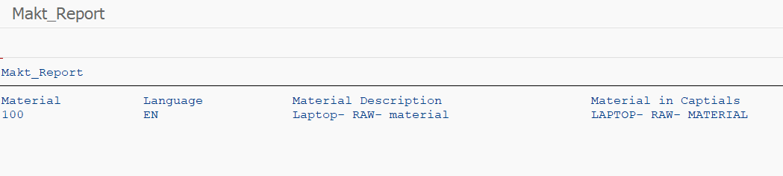

Assignment 02

Write a program to show material description using plant number

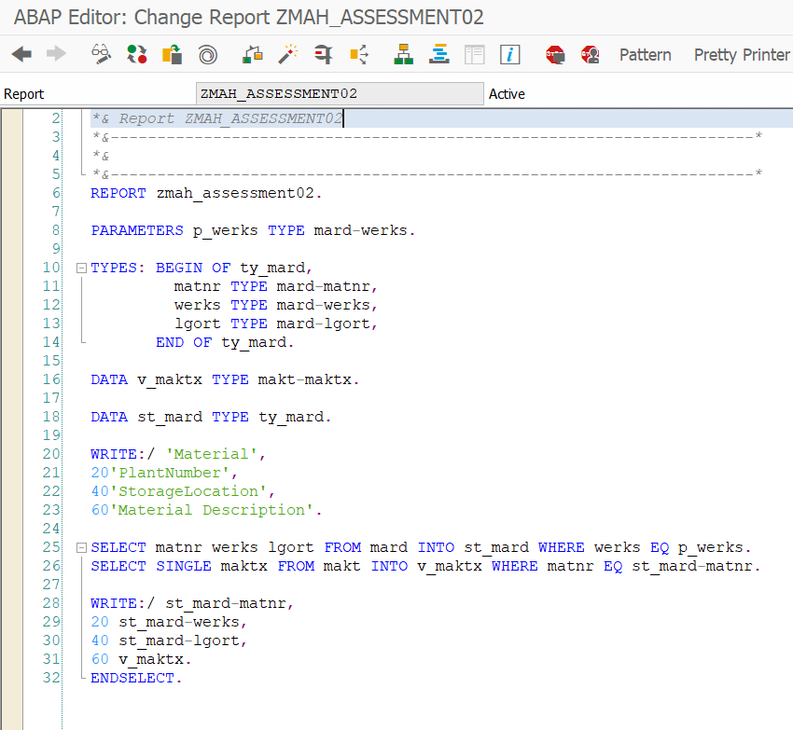

Result:

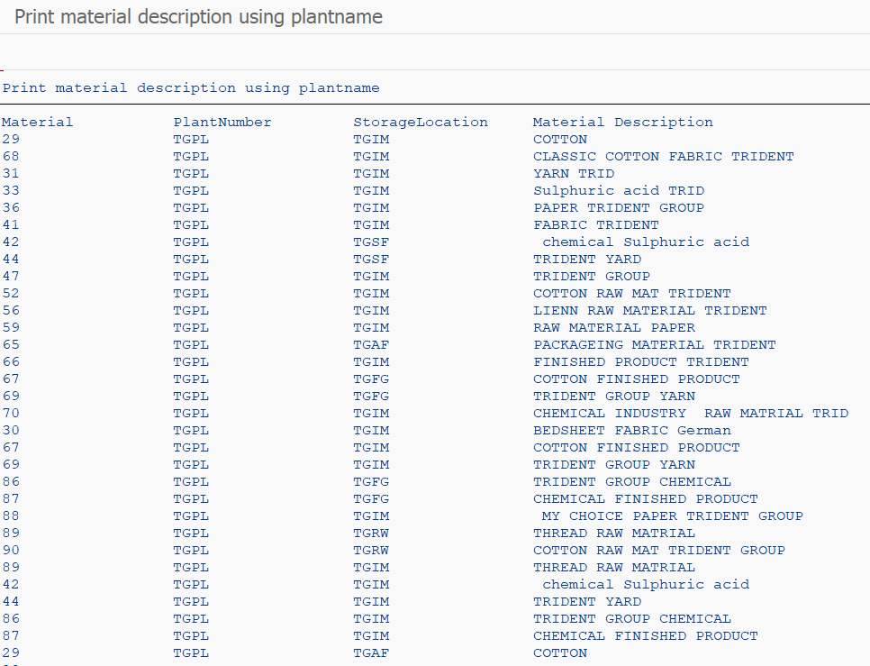

Assignment 03

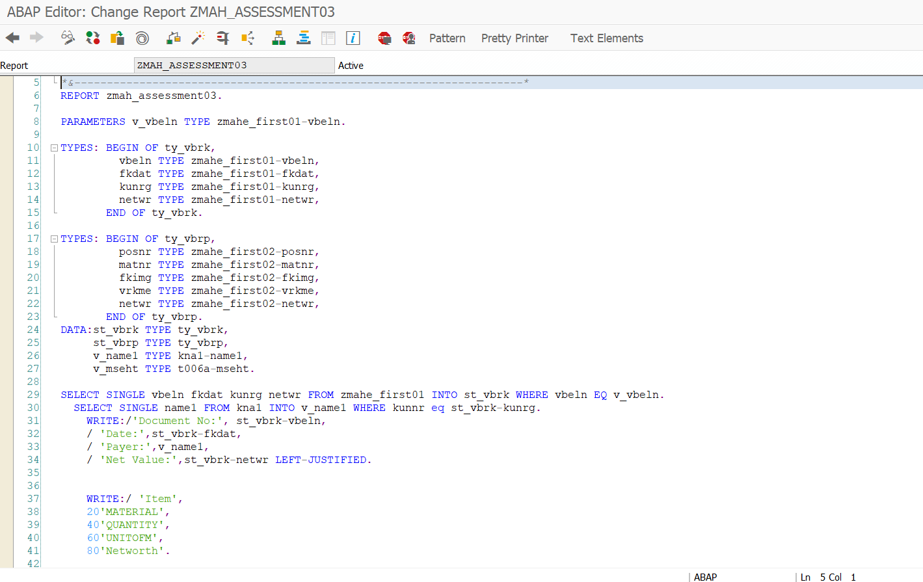

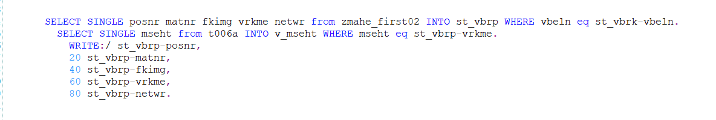

Result:

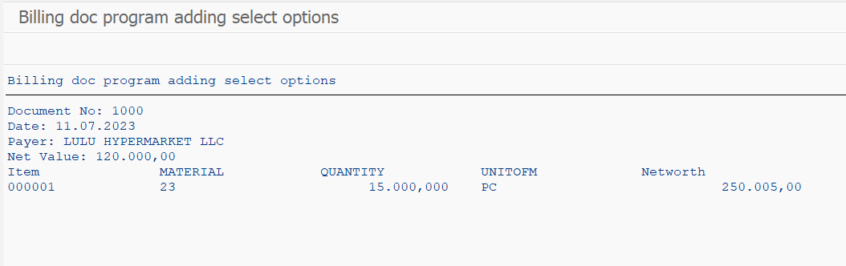

Assignment 4

Internal Table

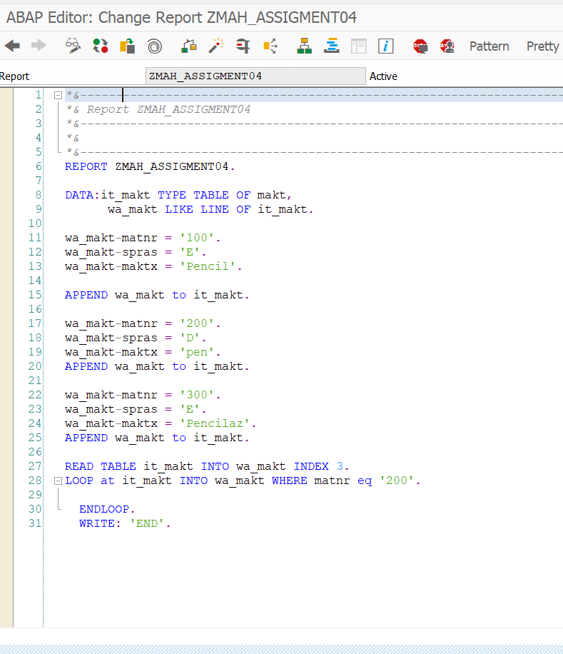Result: 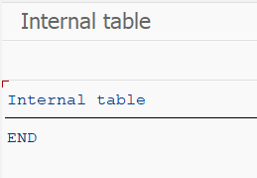

Assignment -05

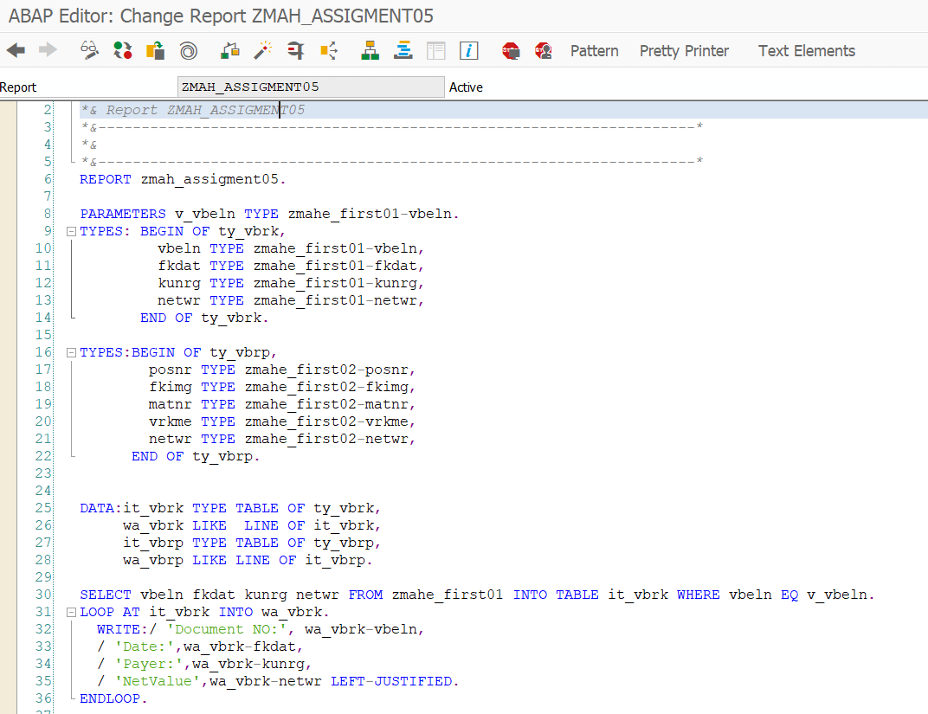

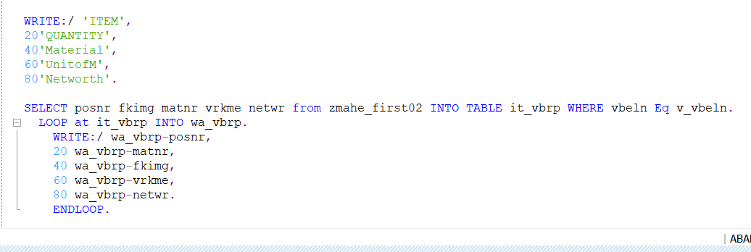

Result: 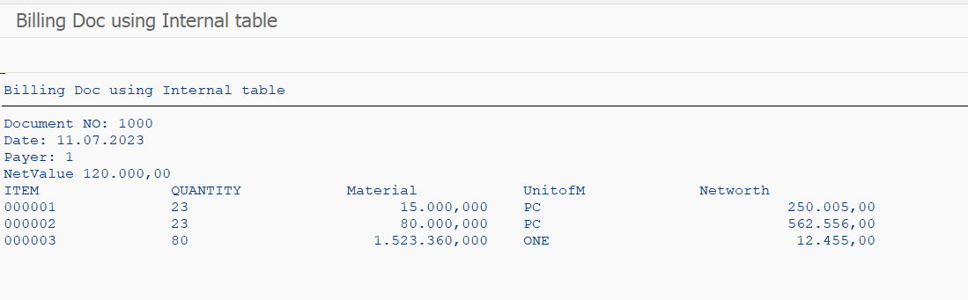

Assignment – 06

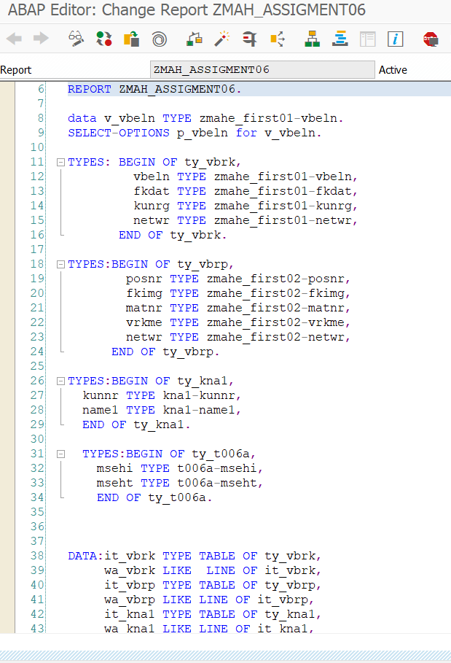

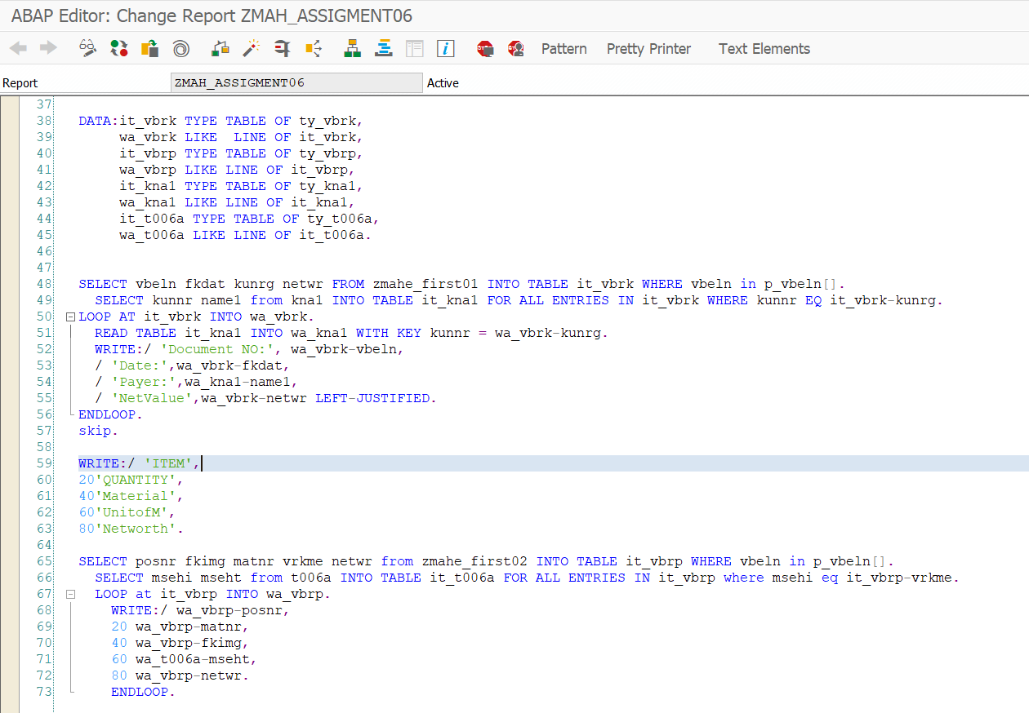

Result:

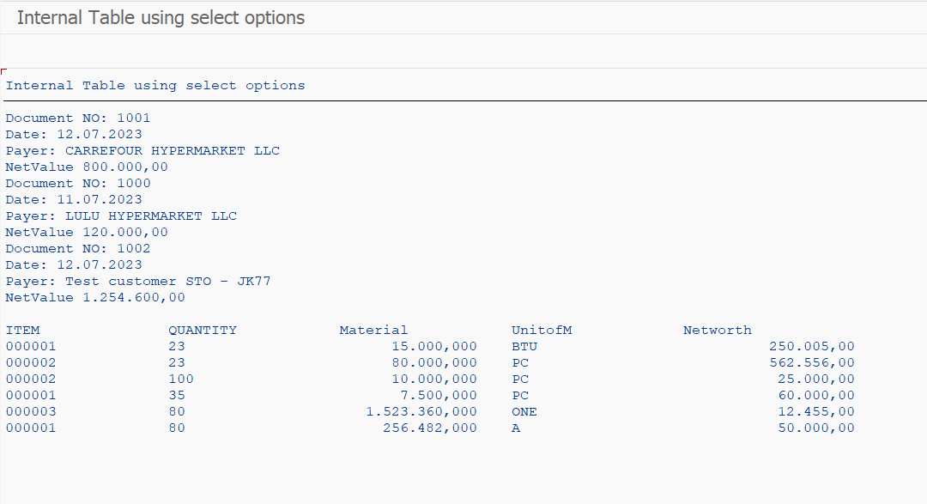

Assignment -07

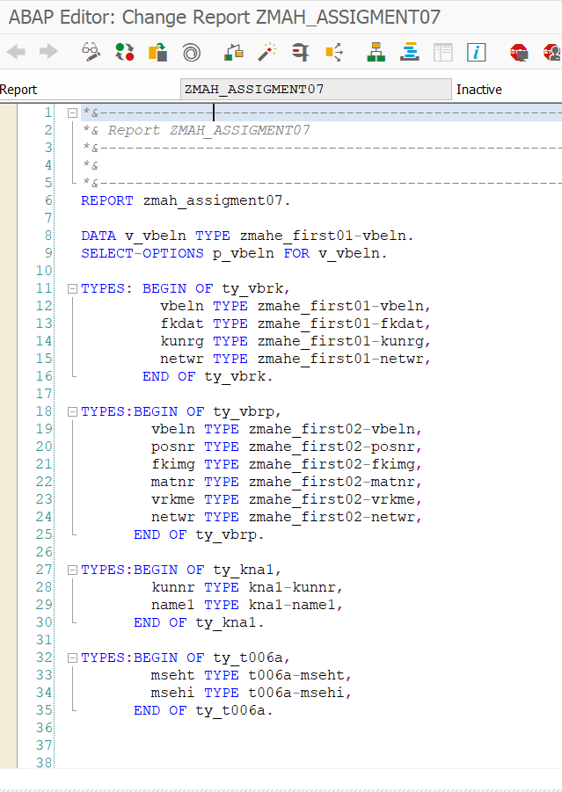

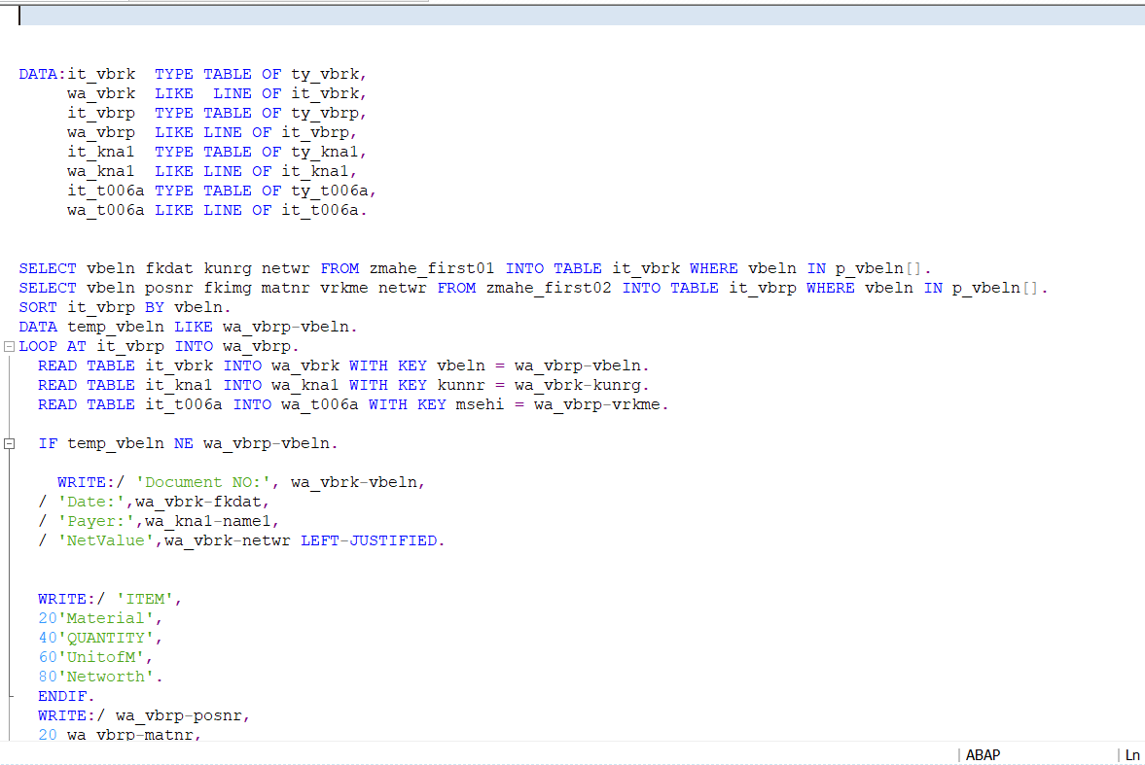

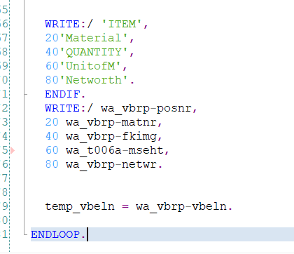

Result:

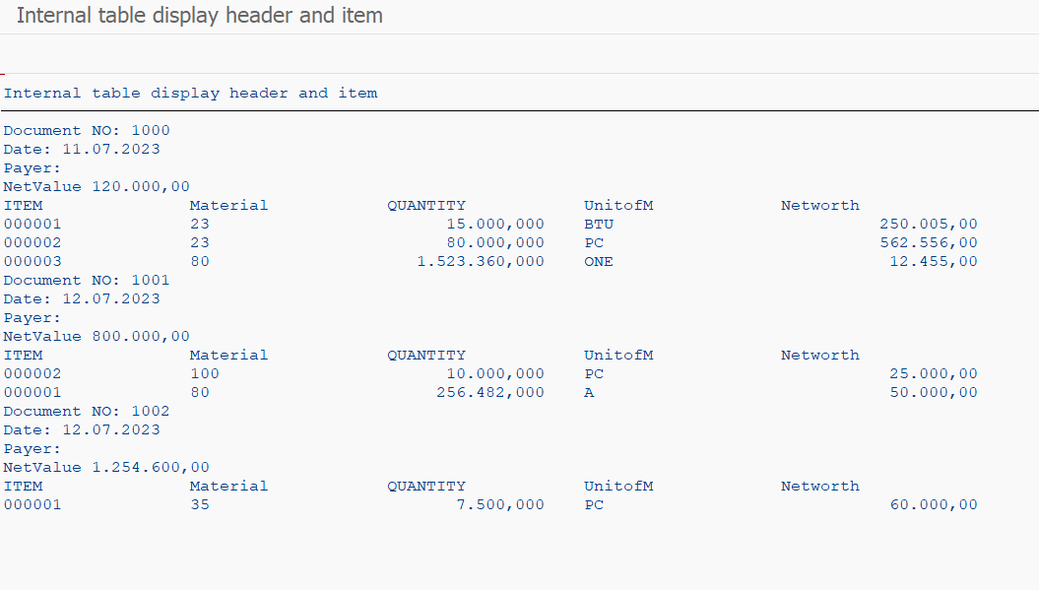

Assignment -08

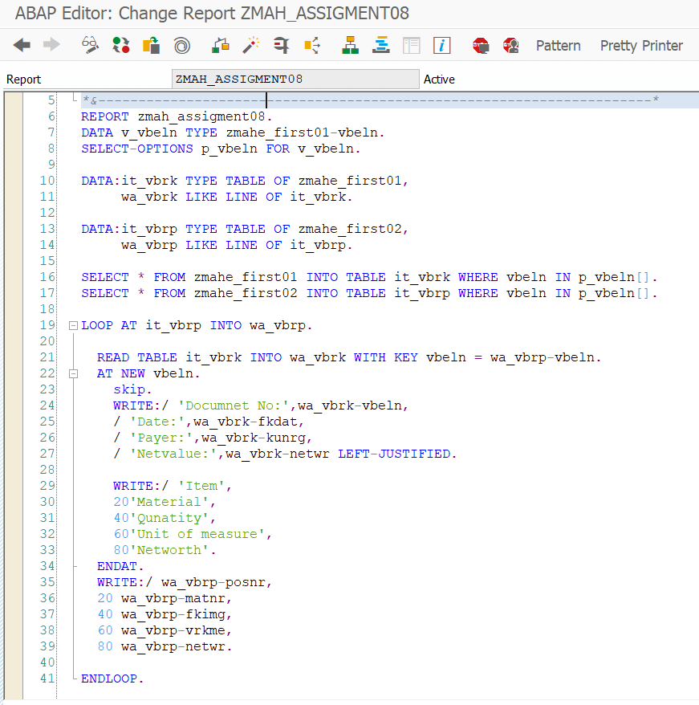

Result:

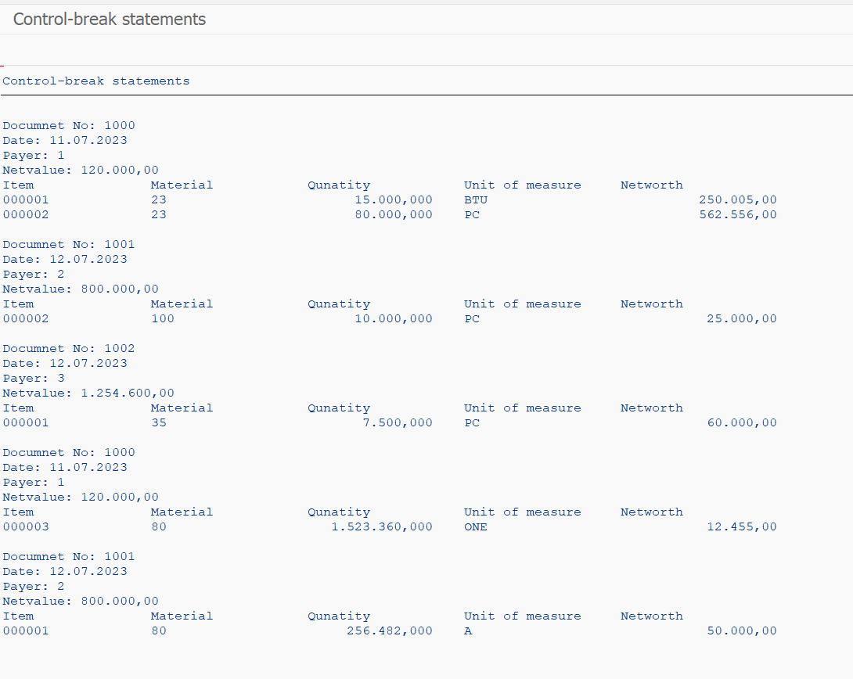

Assignment 09

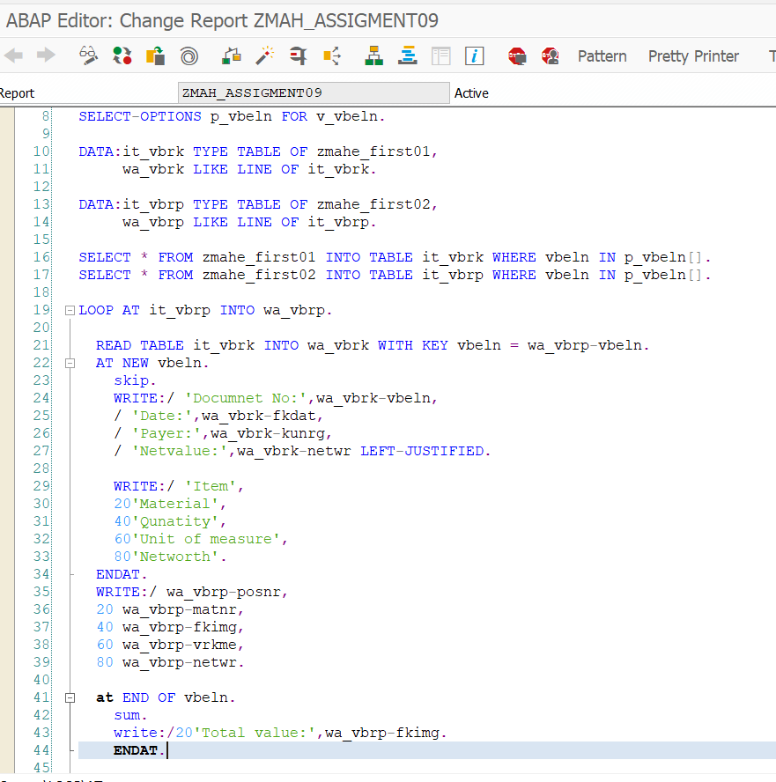

Result:

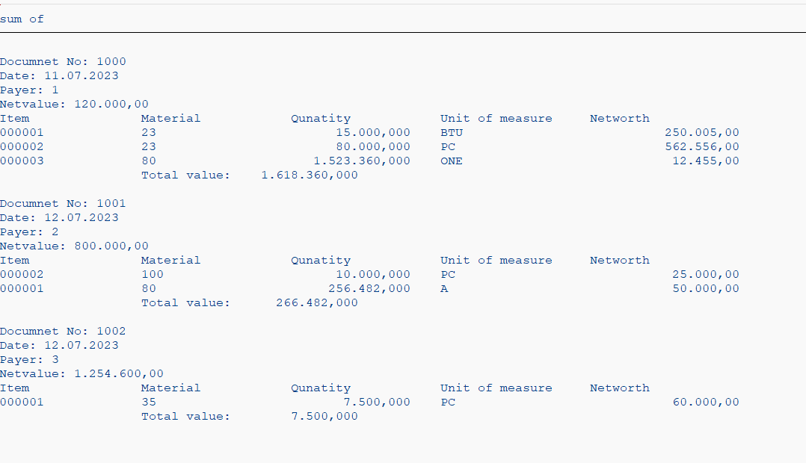

Assignment 10

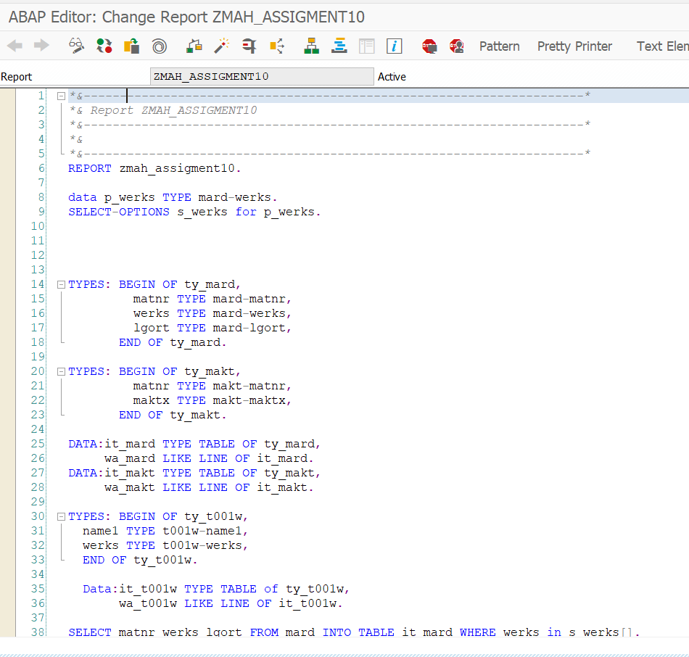

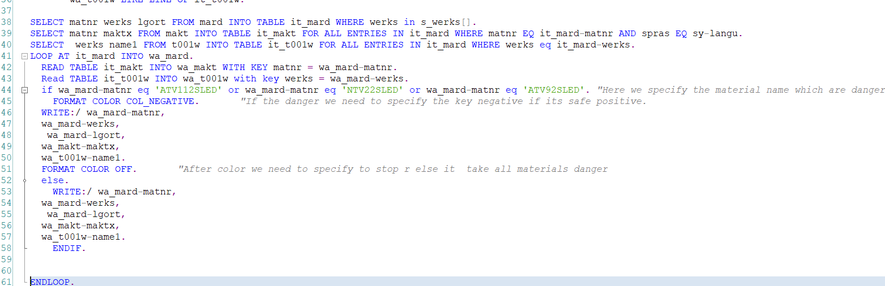

Result:

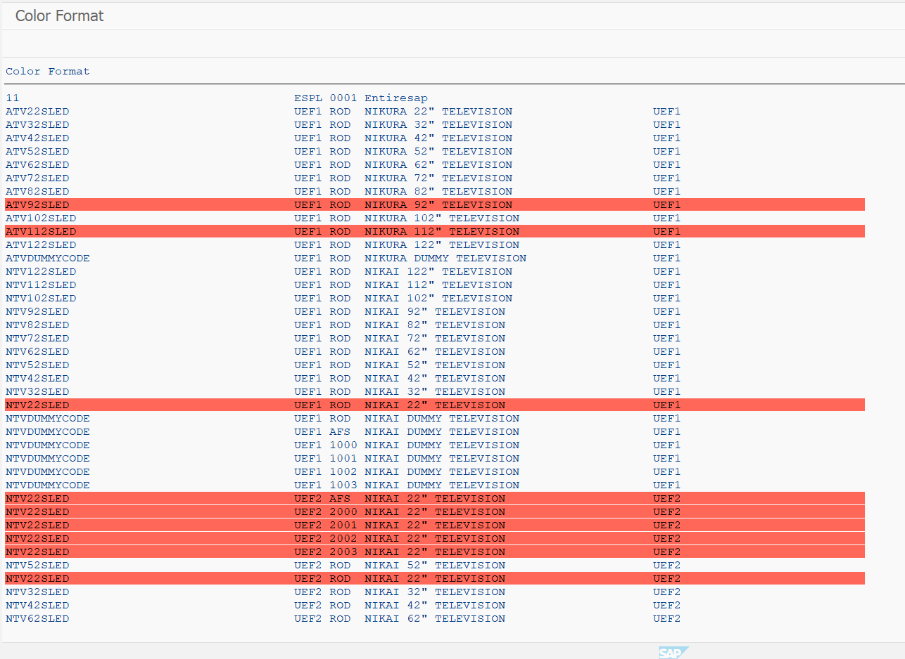

Assignment 11

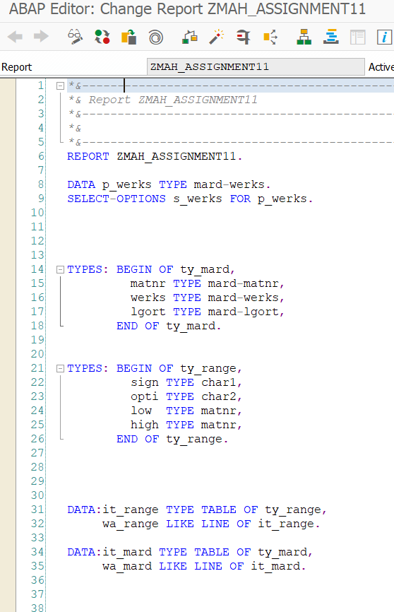

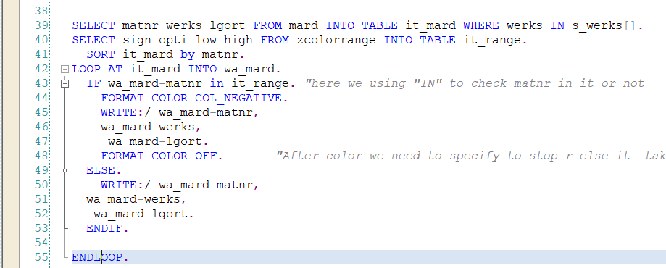

Result:

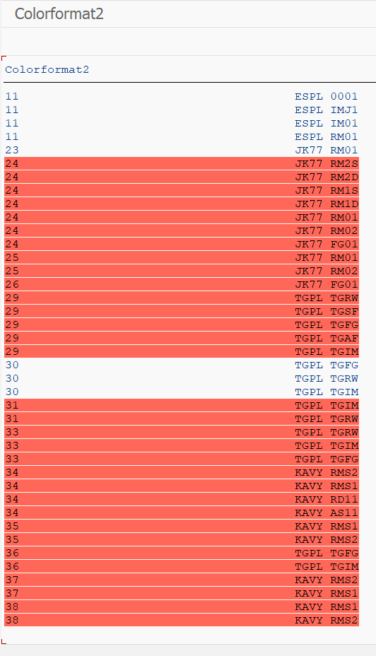

Assignment 12

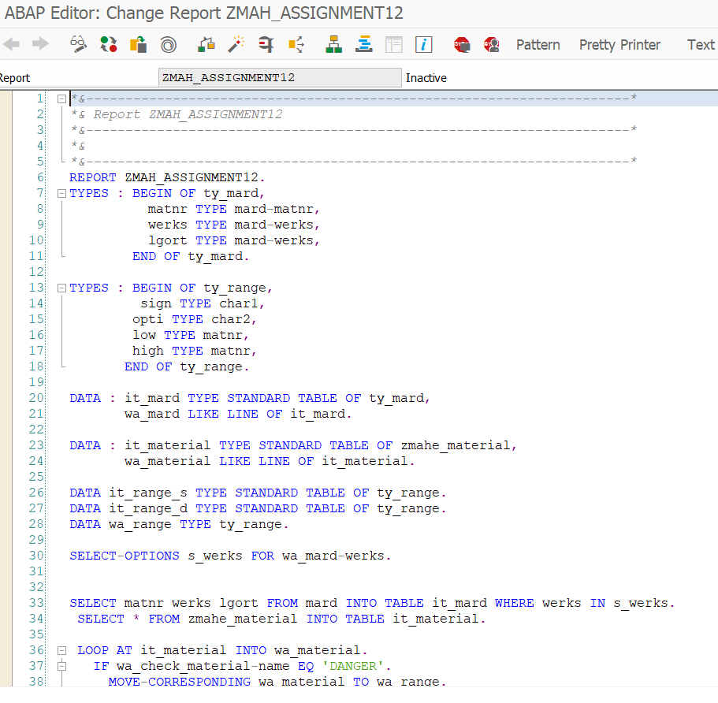

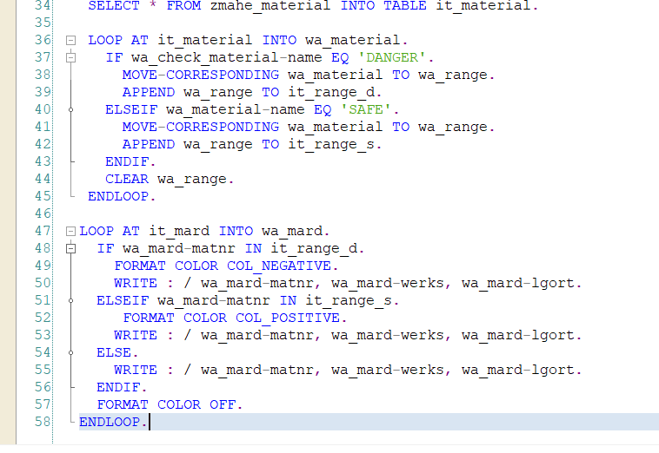

Result:

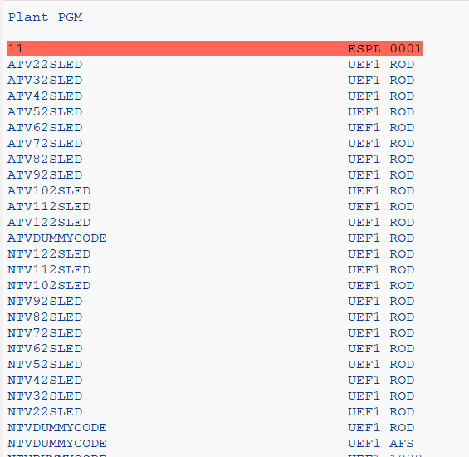

Assignment 13

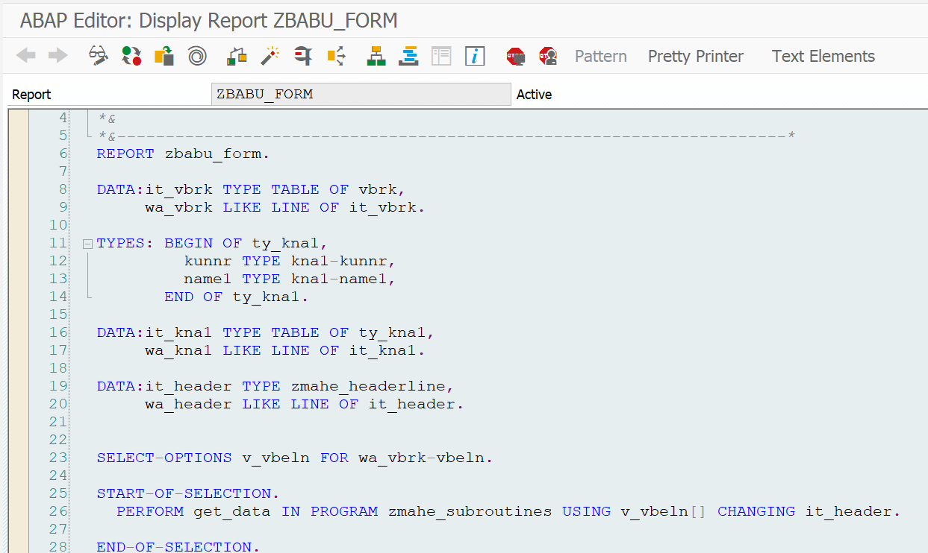

SUBROUTINES

Result:

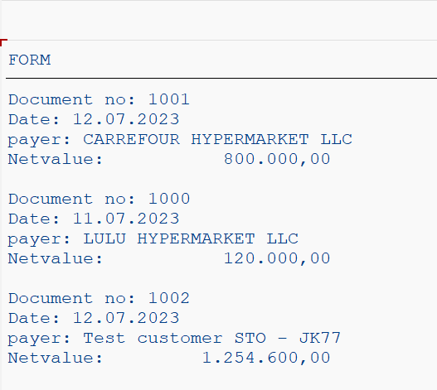

Assignment 14

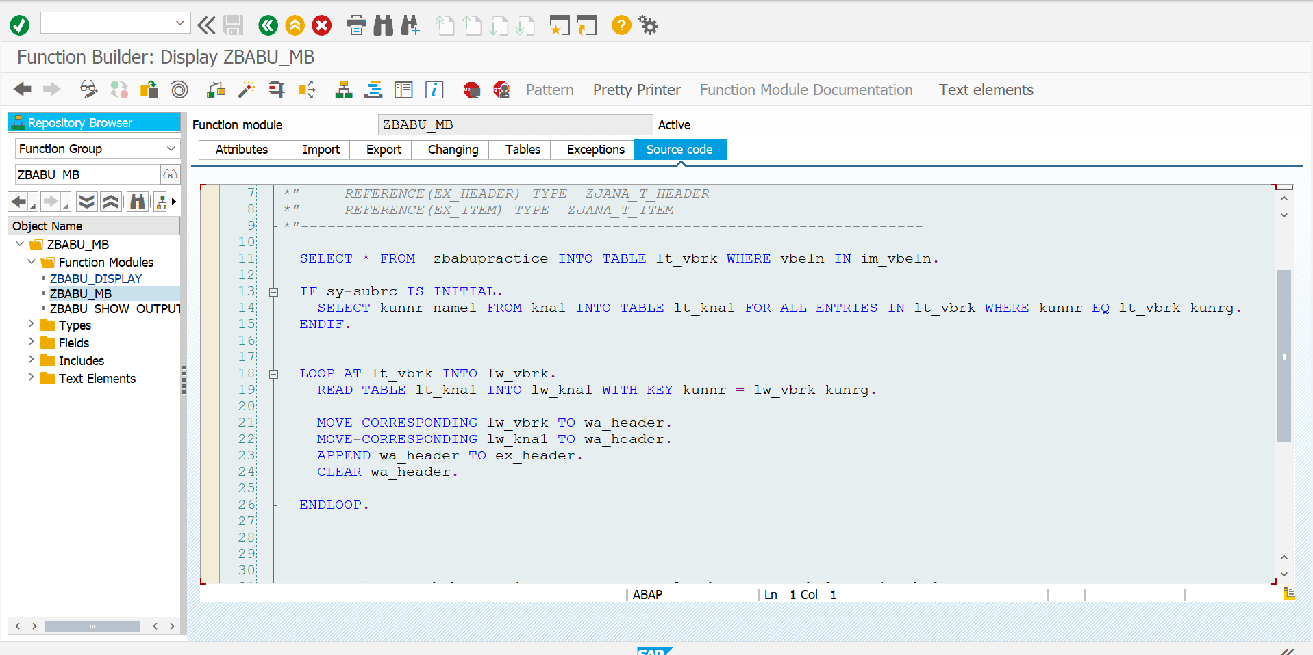



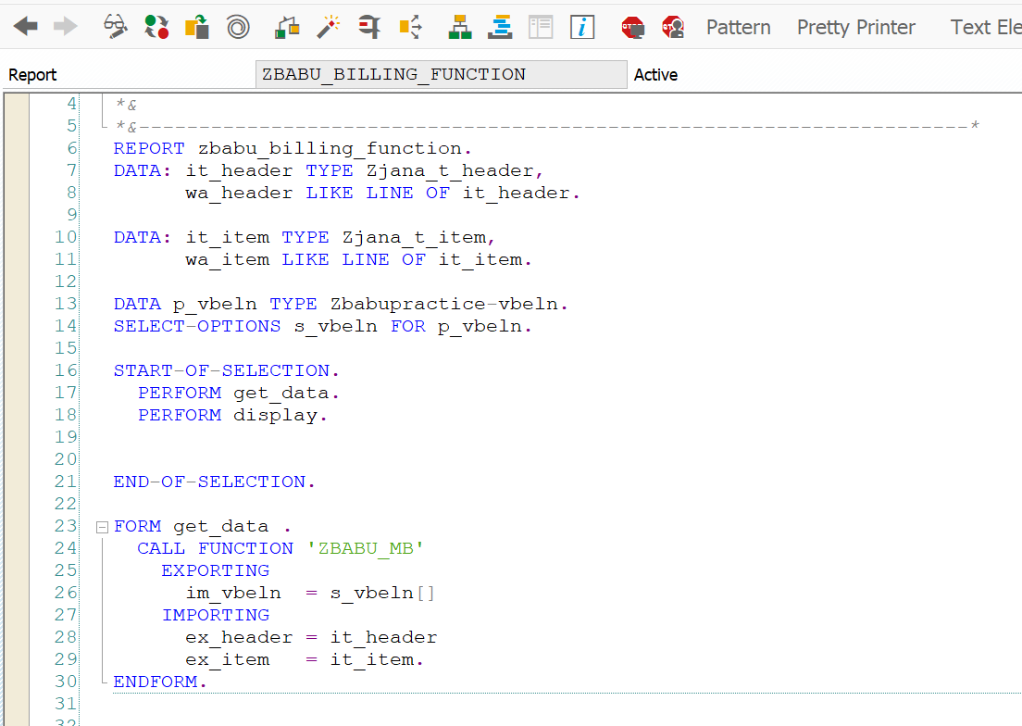

Result:

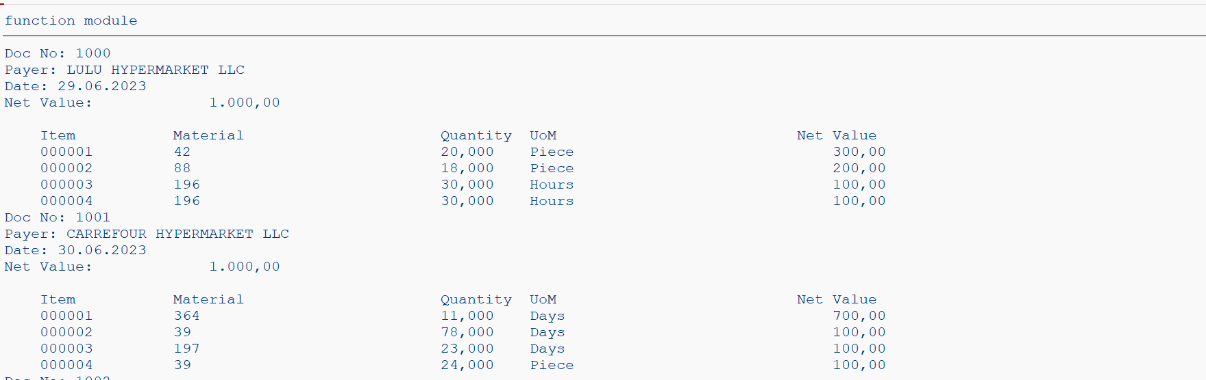

ASSIGNMENT 15

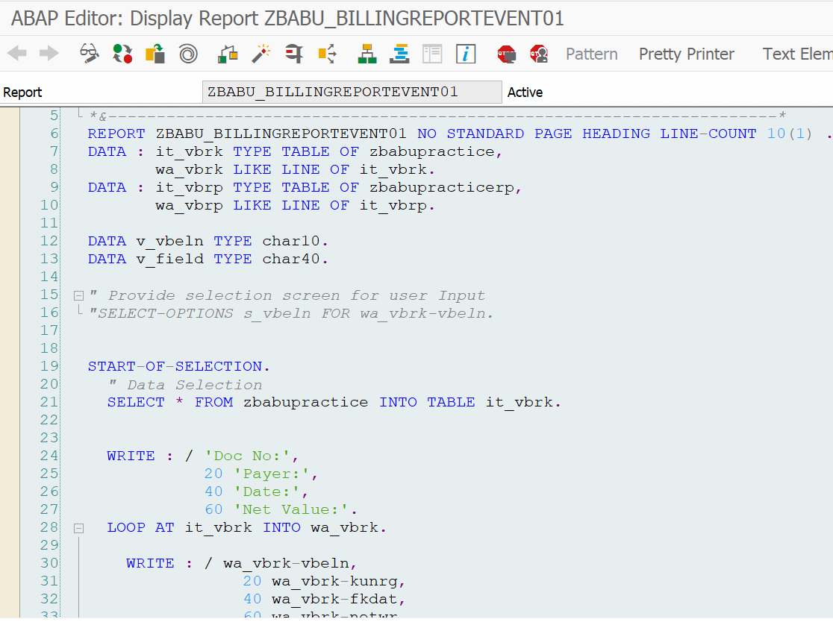

Result:

Assignment 16

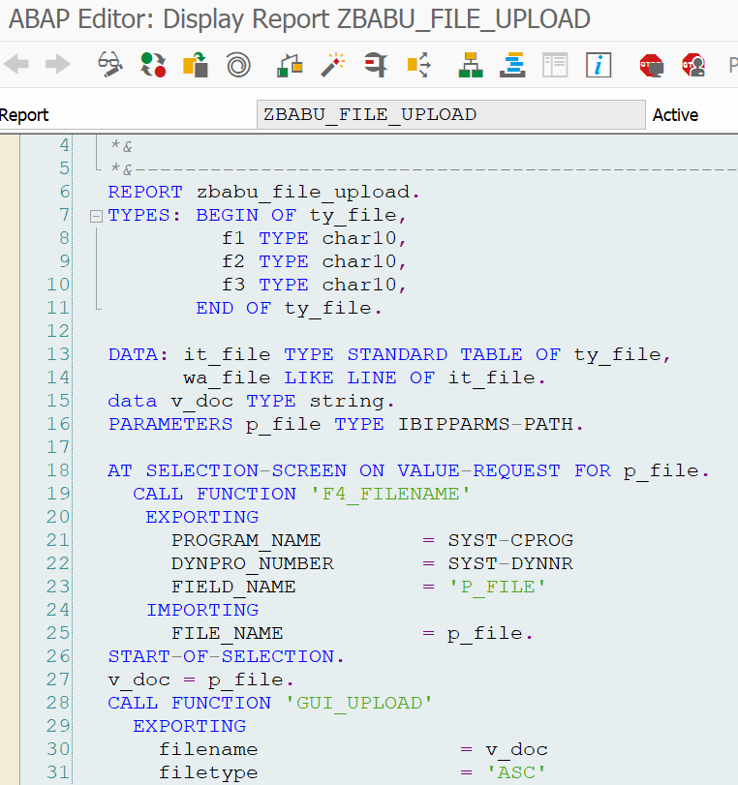

Assignment 17

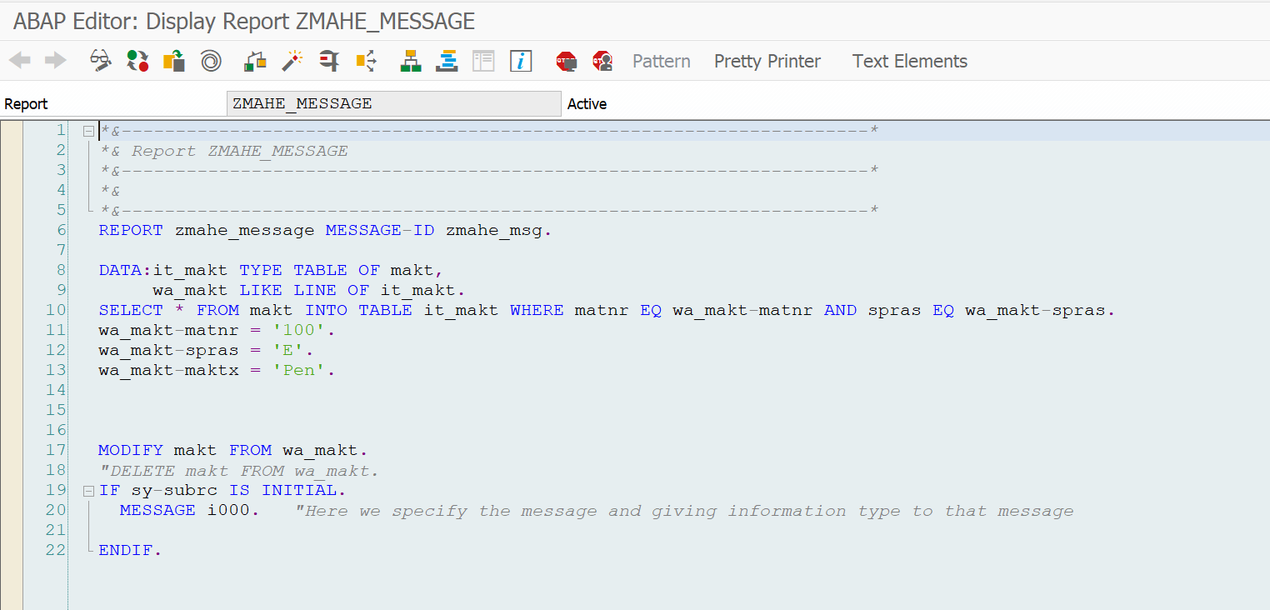

Assignment 18

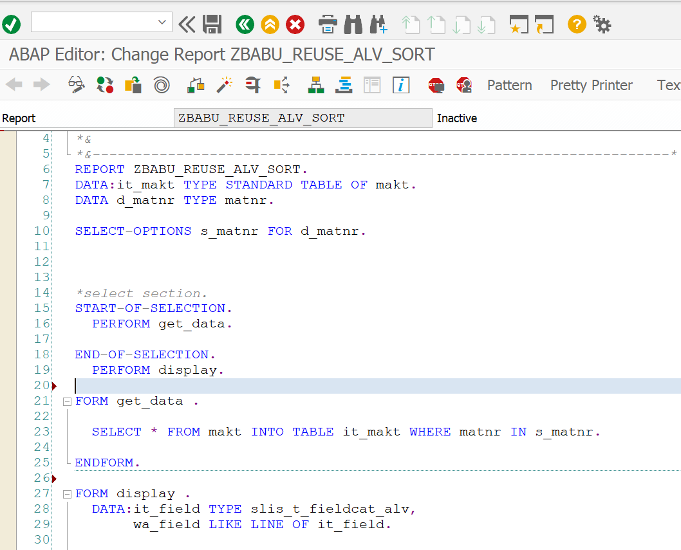

Result:

Assignment 18